Vocational Profile- Additional Questions
Name: Date Completed:
Age: 16-17 18-24 Gender: Male Female Prefer not to say
Below is a list of additional questions to be used to develop a full vocational profile to support the finding of a suitable workplace for you.
Why do you want to do work experience?

circle
Go through the questions and the answers which matches you closely:
  About Me, I am: | Quiet Loud Shy  Confident Energetic Chatty  Anxious Cheerful Moody  Helpful Friendly Flexible  Reliable Calm Hardworking  Sensitive Independent Trustworthy  Keen to learn
Notes:

How Do I travel? | 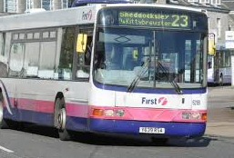 | 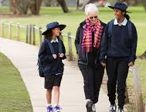 | 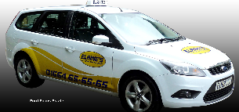
How Do I travel? | Public Transport : | Parent / Support : | Other / Walk / Taxi :
Which type of Work experience is for me? - Duration / Days / Times / Dates. | Short Term | Medium Term | Long Term
 | Details:
Do I have a freedom pass: Yes No

My likes: Please circle one from each question, the one that describes you best
I like to wear |  | 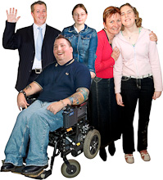 | 
I like to wear | Smart Clothes | Smart Casual | Casual
At work I would like to wear | 
At work I would like to wear | A uniform | My own clothes
Notes:

I prefer to work |  | 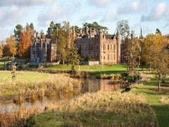
I prefer to work | Indoors | Outdoors
I like it when it is |  | 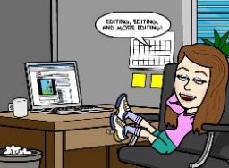
I like it when it is | Busy- lots of things to do | Quiet- with only a few things to do
I like being with | 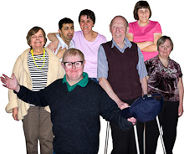 |  | 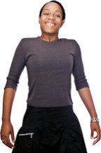
I like being with | Lots of people | Few people | On my own
My favourite time of day is |  | 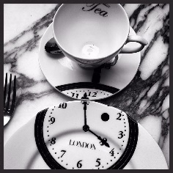 | 
My favourite time of day is | In the morning | In the afternoon | In the evening
My favourite time of day is | 
My favourite time of day is | At night
I like to learn by | 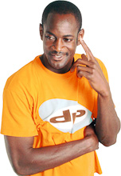 | 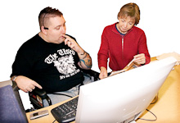 | 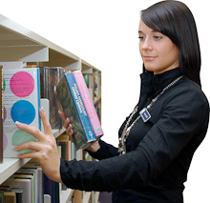
I like to learn by | Listening to others | Being shown what to do | Watching others
I like to learn by | 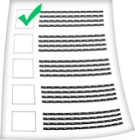
I like to learn by | Following written instructions

Additional comments in relation to questions above: Provide more detail where needed. ( staff to complete with the student)
Eg: Therapies and Communication System, Vison or Hearing impairments, Physical/Motor difficulties and any aids/equipment, Learning / Reading / Writing / Maths/Computer skills, Any other information about Work Place Conditions

These are the jobs, type of workplace settings that interest me- please circle all that apply:
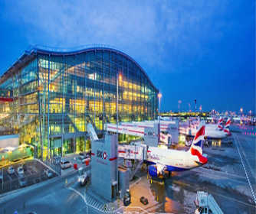  At an airport |  | 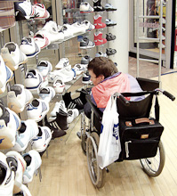  In a shop |   In a supermarket |  |   In a café
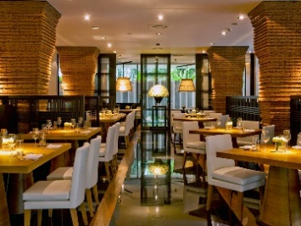  In a restaurant |  | 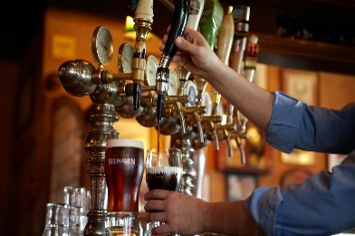  In a pub |   In a fast food place |  | 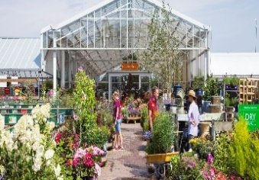  In a garden centre
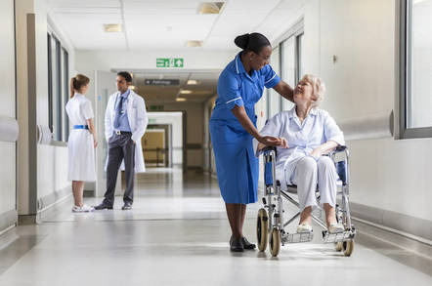  In a hospital |  | 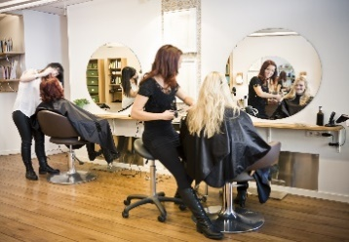  In a hairdressers | 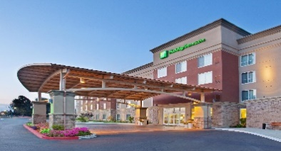  In a hotel |  | 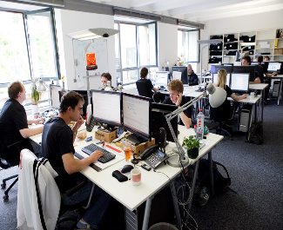  In an office
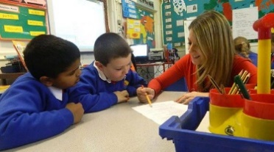  In a school |  | 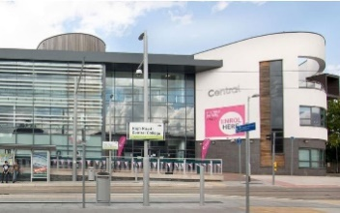  In a college | 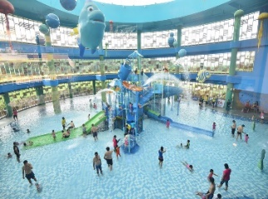  At a leisure centre/gym |  | 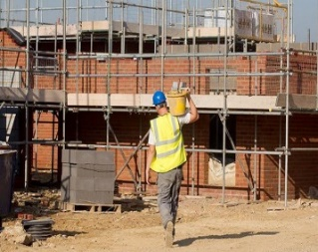  On a building site
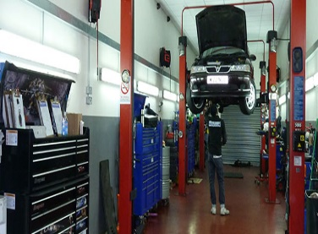  In a garage |  | 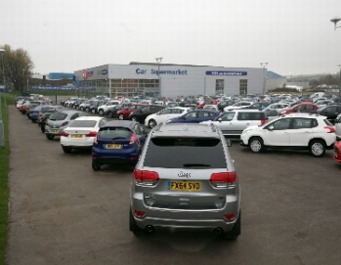  In a car showroom | 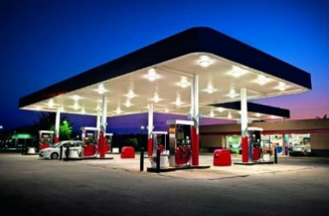  In a petrol station |  | 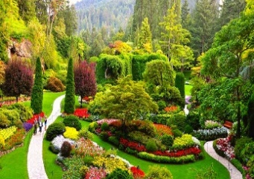  In gardens
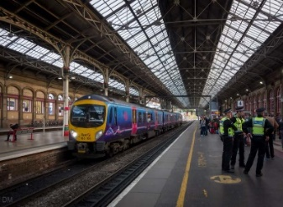  At a train station | 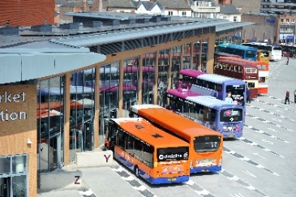  At a bus station |  | 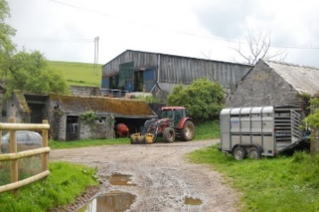  On a farm | 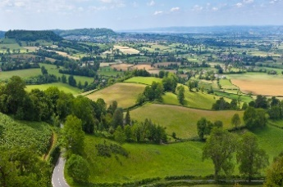  In the countryside
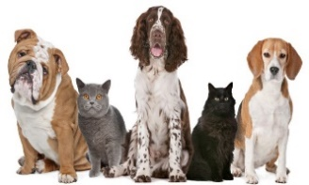  In a cattery/Kennel | 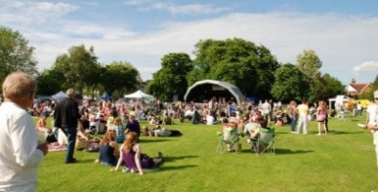  Doing outdoor events |  | 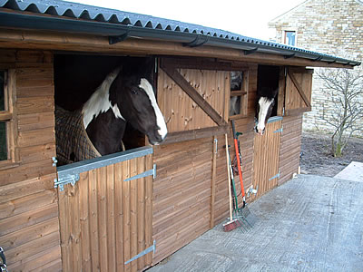  At a stables | 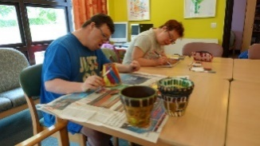  In a day centre
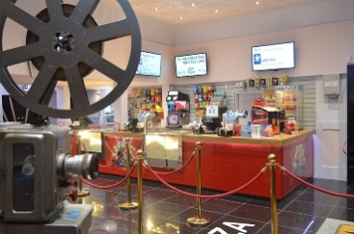  In a cinema | 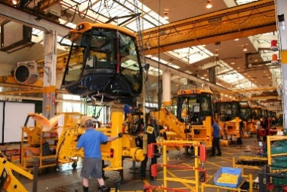  In a factory |  | 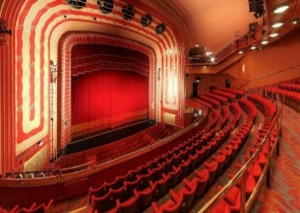  In a theatre | 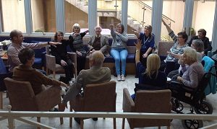  In a care home
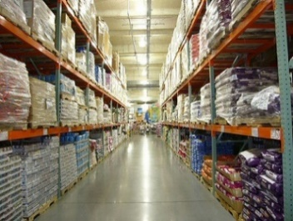  In a warehouse | 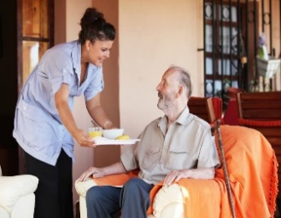  In people’s homes |  | 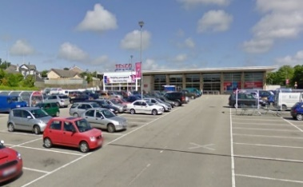  In a car park | 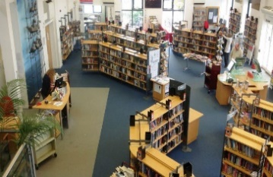  In a library
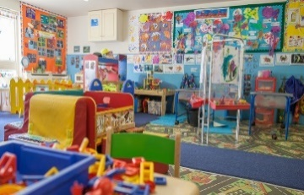
In a nursery

What work experience have you already completed?

What is it about different work environments or jobs you think you would not like?

What are your top three choices of career or job and why?

1.

2.

3.

Which 3 Places would you like to work at right now and why?

1.

2.

3.

What did I like/enjoy about previous work experience?

